|  |
| --- |
| **Year 11 Essentials**  **Major Test 1**  Revision Resources allowed: Calculator and 1 page of notes Total Marks: /45 Total Time: 45mins |

Topics covered: It would be a good idea to use these as sub-headings on your 1 page of notes

* Rates
  + Converting rates into different units
  + Appropriate unit of rates
  + Using rates in practical situations
  + Unitary method
* Number review
  + Leading digit estimation
  + Solve problems relating to percentage increase/decrease and profit/loss eg discounts, GST
  + Best buy problems
  + Using formulas- substituting
  + BIDMAS- order of operations

**In major tests you will be using the knowledge you have reviewed over the past 7 weeks and applying it in real-life situations.**

1. Convert:  
   a.  60 km/h to m/s

b.  40 m/s to km/h

1. The maximum speed of an escalator in a commercial building is set at 0.4m/s. Convert this to the following units.
2. Metres per minute
3. Metres per hour
4. Kilometres per hour.

2. What are the units you would use to measure the speed of;

a) a car

b) running race

1. a worm
2. Lauren’s parents have a Commodore that has a fuel consumption rate of 11.5L/100km on city cycle and 7.5L/100km in highway cycle.
   1. If they purchase petrol at 82.5c/L, how much will it cost them for fuel to travel 450km in the country (highway cycle)?
   2. How far could they travel in the country with a 55L fuel tank?
   3. If they purchase petrol at 75.5c/L, how much will it cost them for fuel to travel 450km in the city (city cycle)?
   4. How far could they travel in the city with a 55L fuel tank?

5. Use leading digit estimation to answer these. **DO NOT GIVE EXACT ANSWERS.** Show working out.

1. 147 x 67
2. 318 + 408 + 97
3. 480 ÷ 52
4. 5786 – 1792

6. a) GST of 10% needs to be added to all the following prices. What will the final prices be once GST has been added? Show working out.

a) $15.40

b) $145

b) Kmart is advertising a sale. Given the original prices calculate the sales price for each of the following. [1,1]

1. $22 discounted by 1/4
2. $85 discounted by 7.5%

7. For each question, calculate the unit rate for each option and determine which one is the BEST buy. Write your final choice in the last column.

The first one is done as an example for you to follow Round all answers to TWO decimal places if necessary

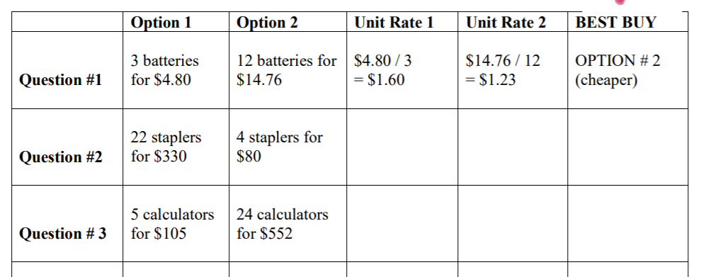

8. To calculate the number of calories we need each day we use the Base Metabolic rate formula.

For males **BMR = 66 + (13.7 x weight) + (5 x height) – (6.8 x age)**

For females **BMR = 655 + (9.6 x weight) + (1.8 x height) – (4.7 x age)**

1. Toby is a 37 year old male who weighs 100kg and is 181 cm. How many calories does he need each day?
2. To convert his calories to Kilojoules he needs to multiply his answer by 4.182. How many kilojoules does Steve require (to the nearest kJ)?
3. How many kilojoules does Toby use every hour (rounded to the nearest kj)?
4. Toby is a computer programmer who has an office job and spends most of his day sitting down. However he does casually walk to and from work each day. He estimates he does the following activities over a 24 hour period.
   * 6 hours sleeping
   * Sitting or standing 12 hours
   * Walking to or from work at a slow pace for a total of 1 hour a day
   * Cleaning the house and other chores 1 hour

Use the list of multipliers below to calculate his exact daily energy needs.

|  |  |
| --- | --- |
| **Physical Activity Level** | **Multiplier** |
| Sleep | 1.0 |
| Sitting or standing | 1.5 |
| Walking Slowly | 3.0 |
| Cleaning and light household chores | 4.0 |
| Cycling at a moderate pace | 8.0 |

9. Shannon earns $20 per hour. She works 24 hours a week at regular pay and another 8 hours a week at time and a half. Luke earns $5600 per month.

Express both pays as a weekly rate and state who earns the most money. Show working out.

10. Calculate the following. Show working out.

1. $14+19 ×10÷5$ =
2. $\left({\left(5+4\right)}^{2}+4\right)+12- 3^{2}$ =